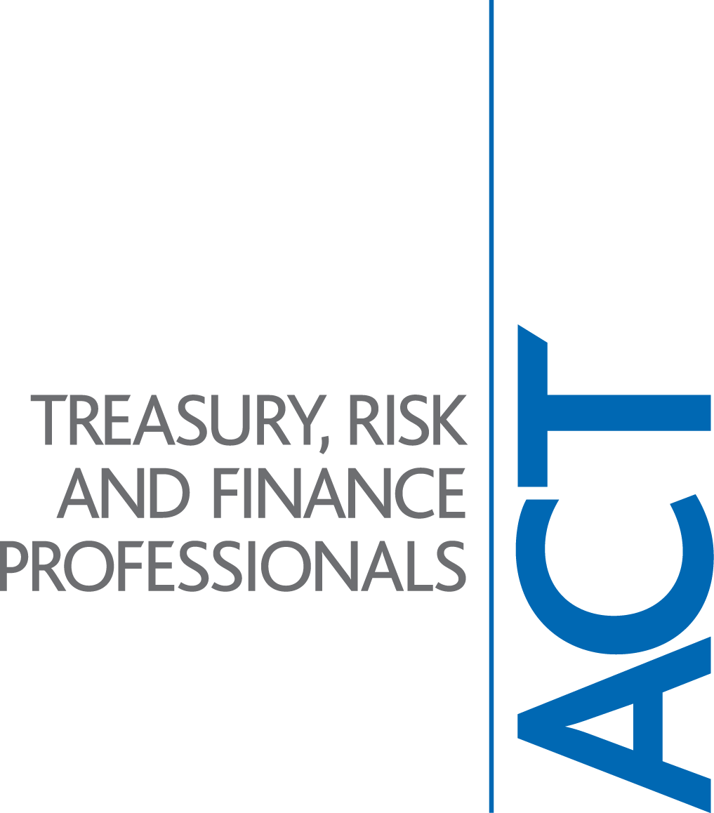

The Association of Corporate Treasurers

Comments in response to
FSA Discussion paper 08/1
'A review of the Structure of the Listing Regime'
January 2008

April 2008

The Association of Corporate Treasurers (ACT)

The ACT is a professional body for those working in corporate treasury, risk and corporate finance. Further information is provided at the end of these comments and on our website www.treasurers.org.
Contact details are also at the end of these comments.
We have canvassed the opinion of our members through our Policy and Technical Committee.

General

The ACT has responded to previous reviews of the UK listing regime and we appreciate the opportunity to contribute to this consultation. Our comments are made from the viewpoint of a non-financial coporate issuer of both debt and equity securities.
This document is on the record and may be freely quoted or reproduced with acknowledgement.

Response

The ACT’s view is that the current regime for debt and equity listings is not in need of a major overhaul. We do believe however that there is considerable value in clarifying the language and labelling of the various forms of UK listing and in making the relevant elements of the FSA website more easily accessible to interested parties. We are in favour of the retention of the UK super equivalent standards as a qualitative enhancement of the minimum EU requirements. The public regulation of these standards should continue to be managed by the FSA.

The ACT is aware of the of the CBI’s paper on this matter and is supportive of their submission

The Association of Corporate Treasurers
The ACT is the international body for finance professionals working in treasury, risk and corporate finance. Through the ACT we come together as practitioners, technical experts and educators in a range of disciplines that underpin the financial security and prosperity of an organisation.
The ACT defines and promotes best practice in treasury and makes representations to government, regulators and standard setters.
We are also the world’s leading examining body for treasury, providing benchmark qualifications and continuing development through training, conferences, publications, including The Treasurer magazine and the annual Treasurer’s Handbook, and online.

Our 3,600 members work widely in companies of all sizes throughout industry, commerce and professional service firms.

Further information is available on our website (below).

Our policy with regards to policy and technical matters is available at http://www.treasurers.org/technical/resources/manifestoMay2007.pdf
.

Contacts:
John Grout, Policy and Technical Director  (020 7847 2575; jgrout@treasurers.org )  Martin O’Donovan, Assistant Director, Policy and Technical  (020 7847 2577; modonovan@treasurers.org)  Peter Matza, Policy and Technical Officer  (020 7847 2576; pmatza@treasurers.org) | The Association of Corporate Treasurers  51 Moorgate  London EC2R 6BH, UK  Telephone: 020 7847 2540  Fax: 020 7374 8744  Website: http://www.treasurers.org
The Association of Corporate Treasurers is a company limited by guarantee in England under No. 1445322 at the above address

